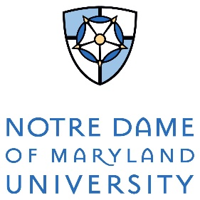
COVID-19 Self-Certification of Ending Mandatory Isolation
Faculty, staff, students, and contractors who test positive for COVID-19 must self-isolate at home or in designated residence hall space and follow CDC guidance prior to returning or entering the campus community.

Notification for return to on-campus activities is directed through the Office of Risk Management & Public Safety and/or the Offices of Student Life, Human Resources, or Auxiliary Services.

Name: _____________________________________
I am:
- Faculty
- Staff
- Student
- Specify if other:
_______________________

Email Address: _____________________________________
Phone Number: _____________________________________

If you tested positive for COVID-19 and had symptoms, please check all that apply:
- I have been fever-free (less than 100.4 degrees) without the use of fever reducers for 24 hours
- Symptoms have improved (e.g. cough, shortness of breath)
- It has been at least 10 days since my symptoms first appeared.

If you tested positive for COVID-19 but had no symptoms, please check all that apply:
- It has been ten (10) days after my positive test

- I did not develop symptoms.

I certify that all information submitted is true and accurate to the best of my knowledge.

Signature ______________________________________ Date _____________________

Students should send the completed form to COVID_SL@ndm.edu. Faculty and staff should send their completed form to COVID_HR@ndm.edu. Contractors and vendors should send their completed form to COVID@ndm.edu.

The following is provided for an individual’s personal use to document his or her symptoms and recovery. This may does not need to be provided to the University but kept for the employee’s personal records.
Date Symptoms Began:_______________________
Date of last fever of 100.4 degrees of higher: _________________________
Date Symptoms began improving: _______________________

Date | Temperature | Other Symptoms? (Y/N) | Other Symptoms or Notes

