**NDMU Partner School Case Study Analysis**

**2022-2024**

**NDMU Partner Schools- NDMU Completer Impact Elementary, Middle, and High School**

**Baltimore County Public Schools**

English/Language Arts



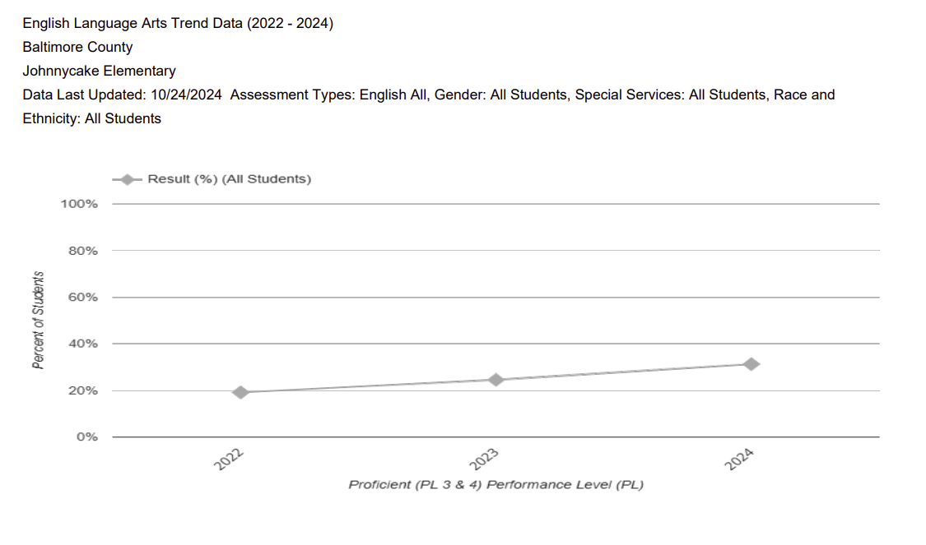

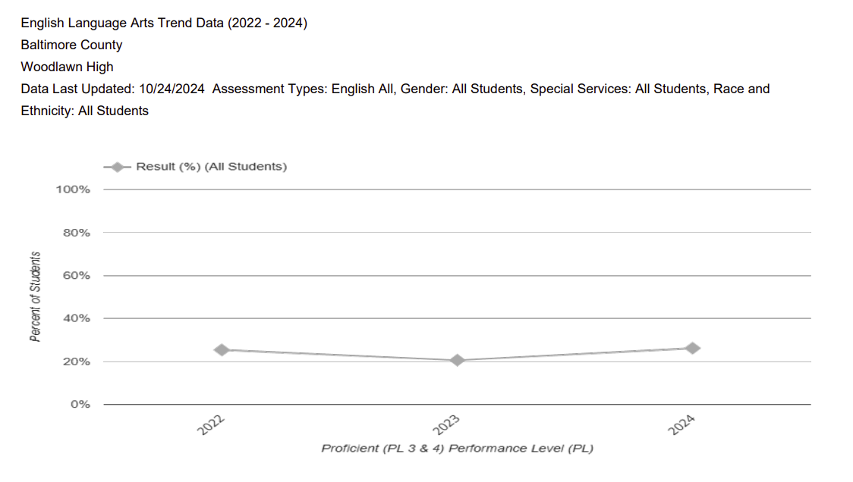

ELA scores have increased in all Baltimore County Partner schools. Hillcrest has seen significant improvement from 63.8% student proficiency in 2022 to 72.85 in 2024. Likewise, Johnnycake scores increased from 19.2% to 31.35 in that same timeframe. While Woodlawn has made less significant increase in scores and had a decrease in 2023, they increased from 25.6% proficiency in 2022 to 26.2% in 2024.

Baltimore County Math Scores

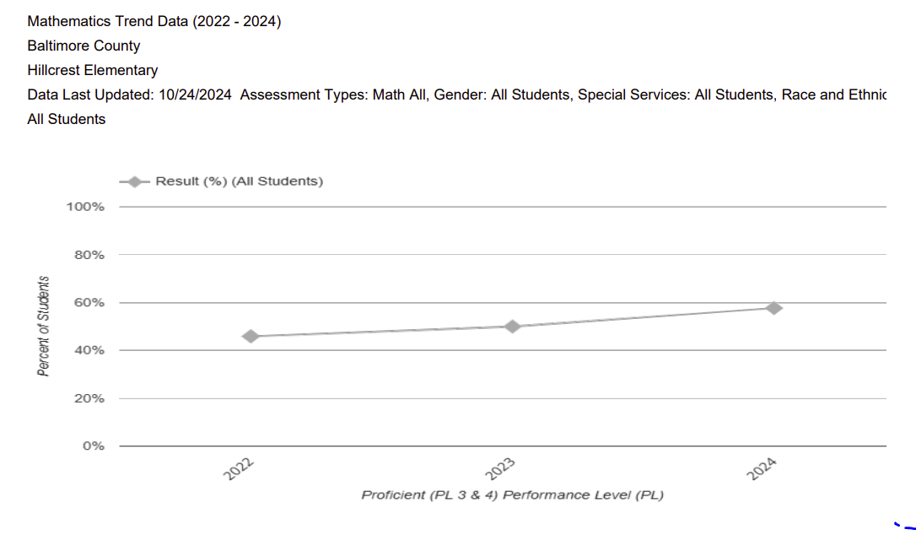

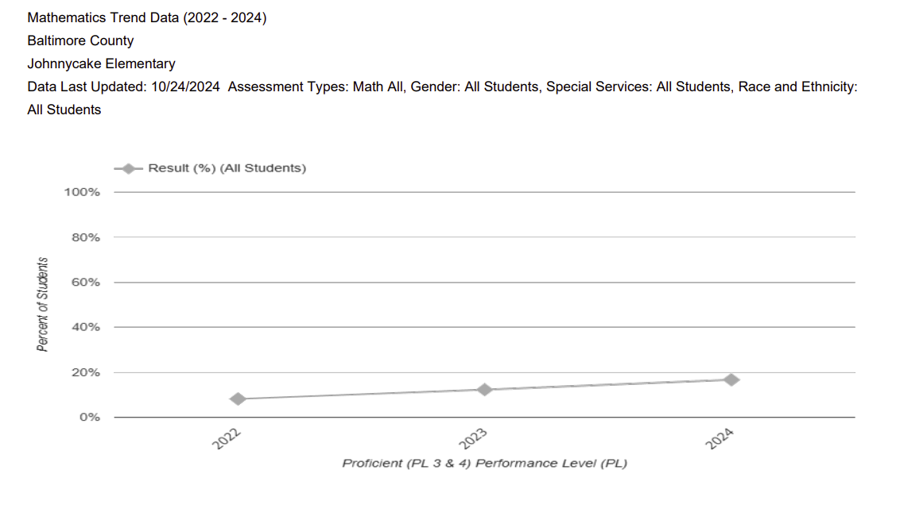

Both 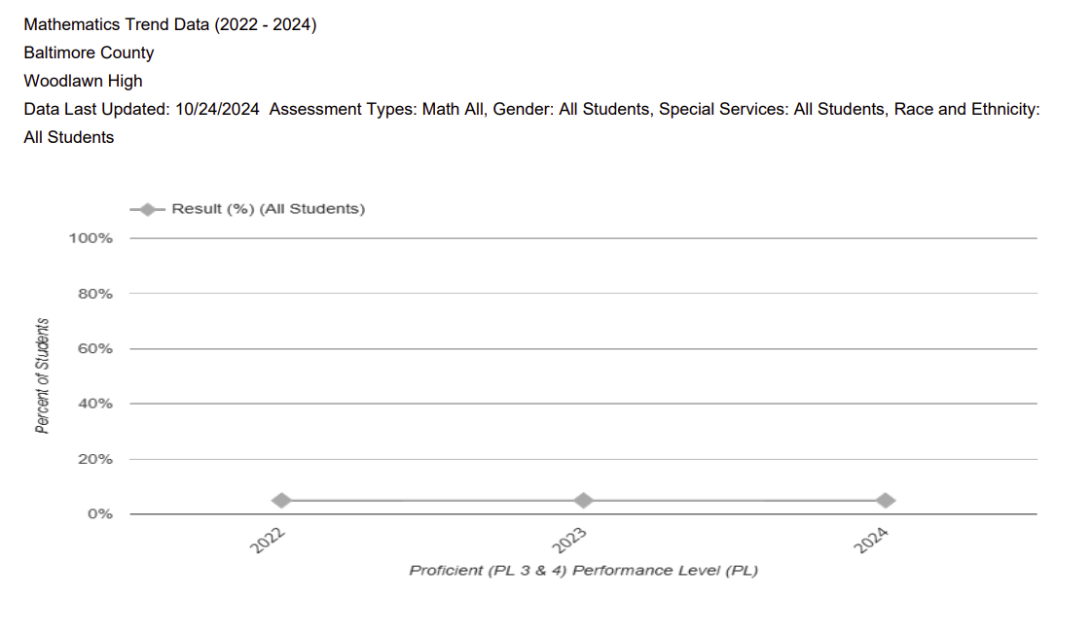

Both of the Baltimore county elementary schools have had sustained increases in math student proficiency with Hillcrest increasing from 45.9% in 2022 to 50% in 2023 and 57.7% in 2024. Johnnycake has increased from 8.2% in 2022 to 12.3% in 2023 and 16.7% in 2024. However, Woodlawn High School has remained at less than 5% of their students proficient in mathematics which as been a priority in our partnership.

**Anne Arundel County Public Schools**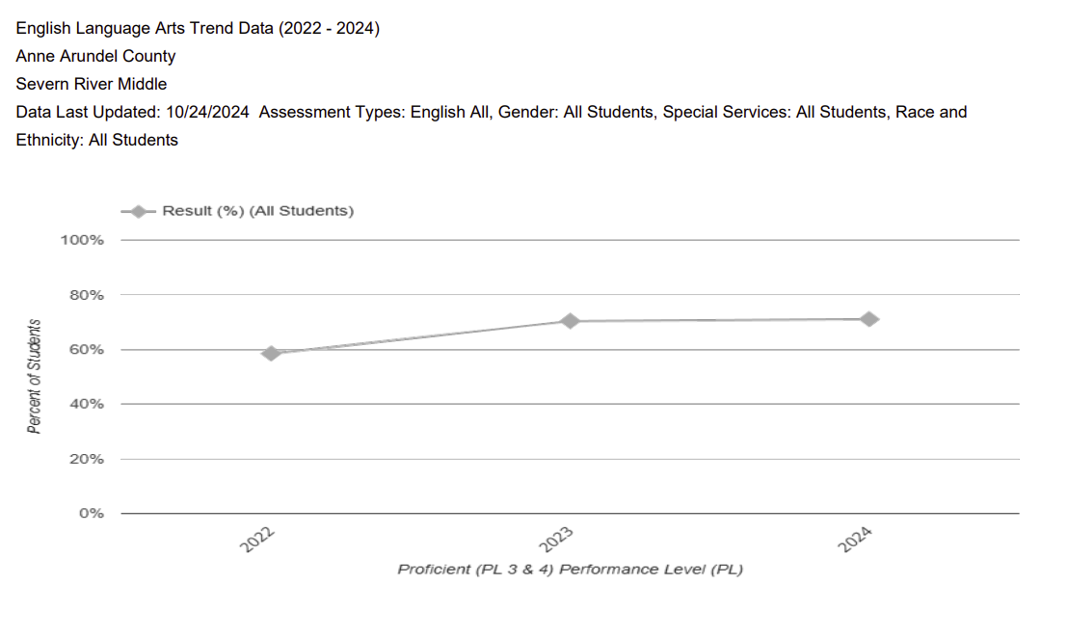

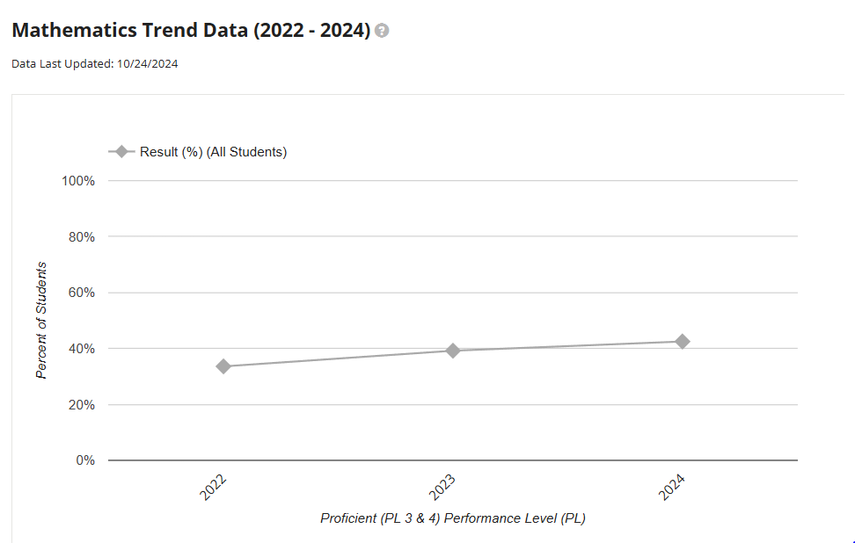

Over the past three years, Severn River, our partner school in Anne Arundel County has increased student proficiency in both ELA and mathematics. In ELA student proficiency increased from 58.5% in 2022 to 71.1% in 2024. In mathematics, student proficiency increased from 33.6% in 2022 to 42.5% in 2024.

**Baltimore City**

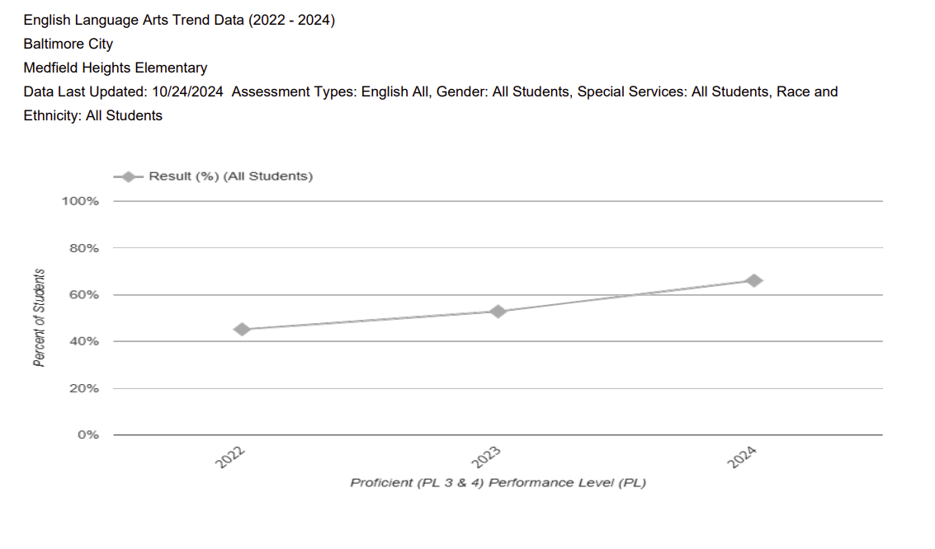

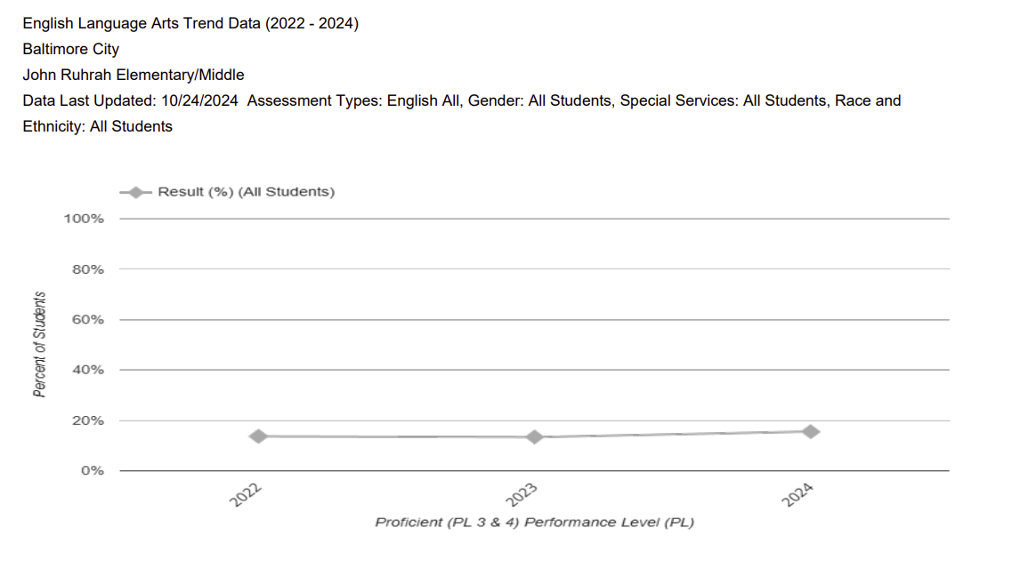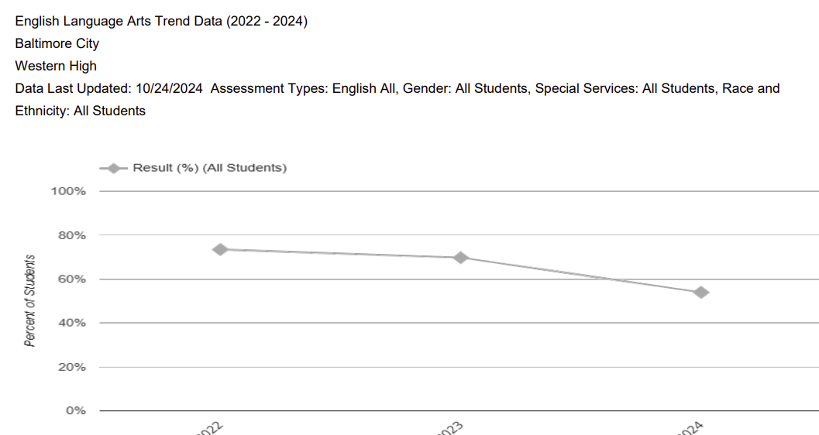In ELA, Medfield Heights has had significant increases from 45.2% student proficiency in 2022 to 66.1% in 2024. John Rurah has had a small increase from 13.7% student proficiency in 2022 to 15.6% in 2024. However, Western High has had a steady decrease in ELA scores from 73.5% in 2022 to 54% in 2024. This is a focus of our partnership.

Math

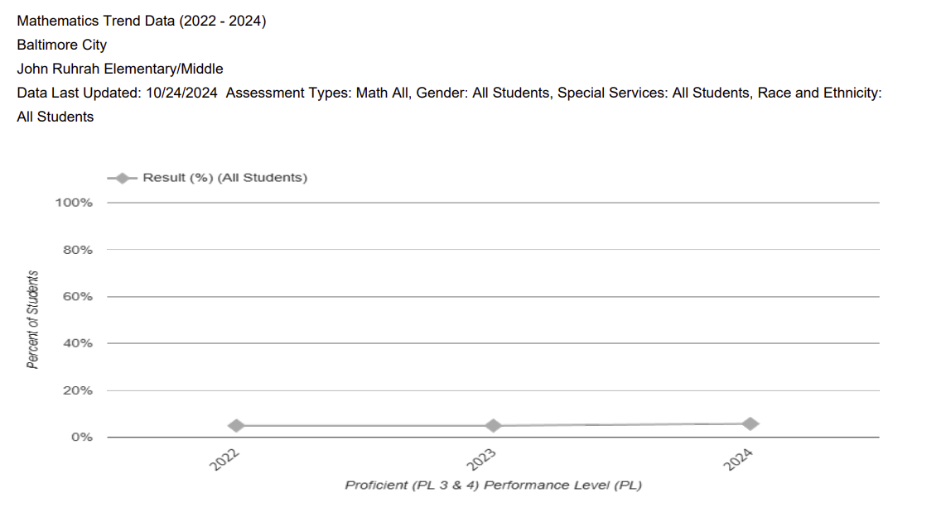

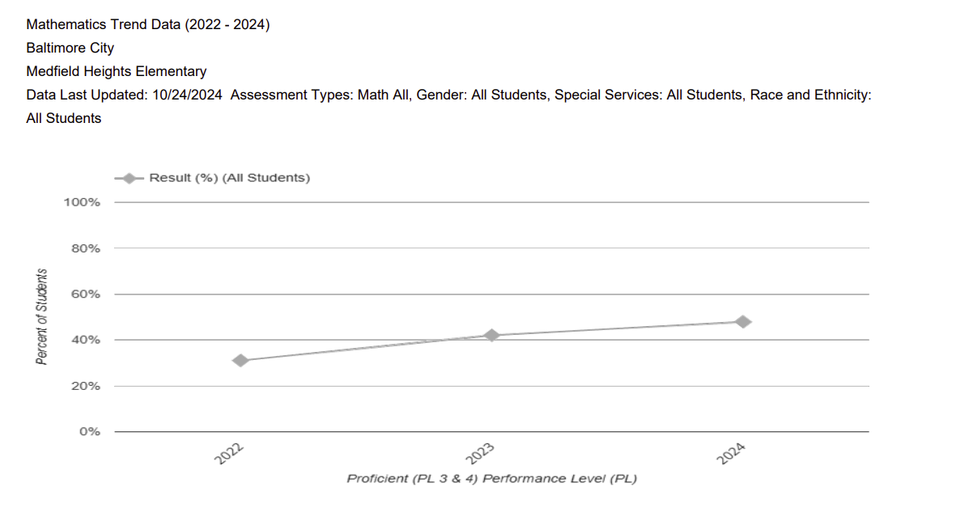

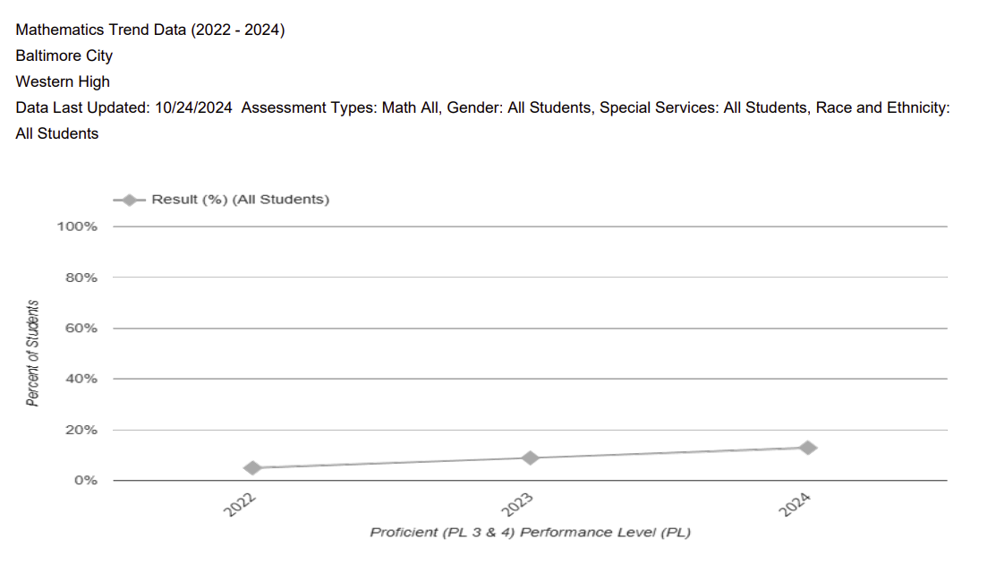

Scores at all partner schools in Baltimore city, while some minimal, have had increases in student proficiency in mathematics. Medfield scores have increased from 31.1% in 2022 to 47.9% in 2024. John Rurah, with a high percentage of multilingual learners, has seen a minimal increase in scores from less than 5% student proficiency in 2022 and 2023 to 5.8% in 2024. Western High School has had an increase from less than 5% in 2022 to 12.9% in 2024.

**Harford County**

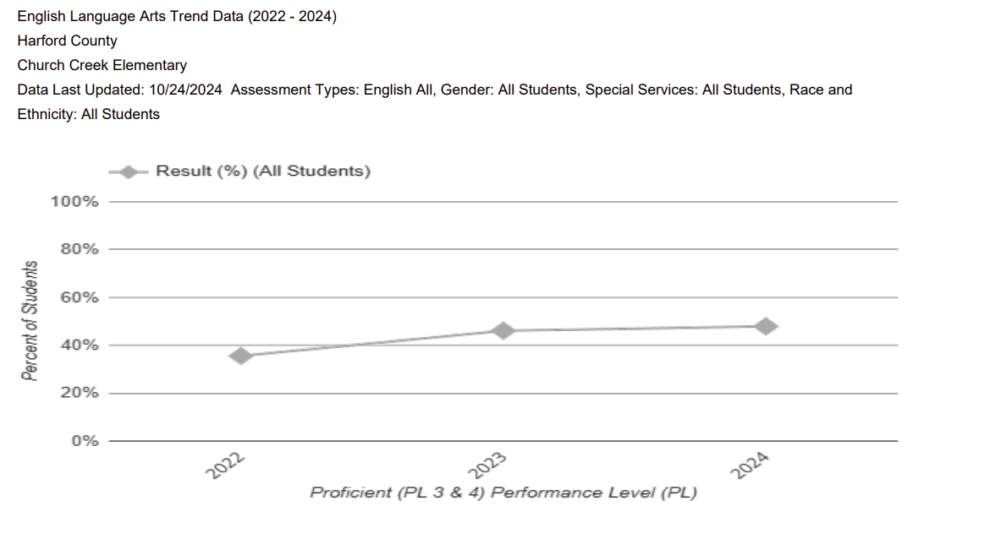

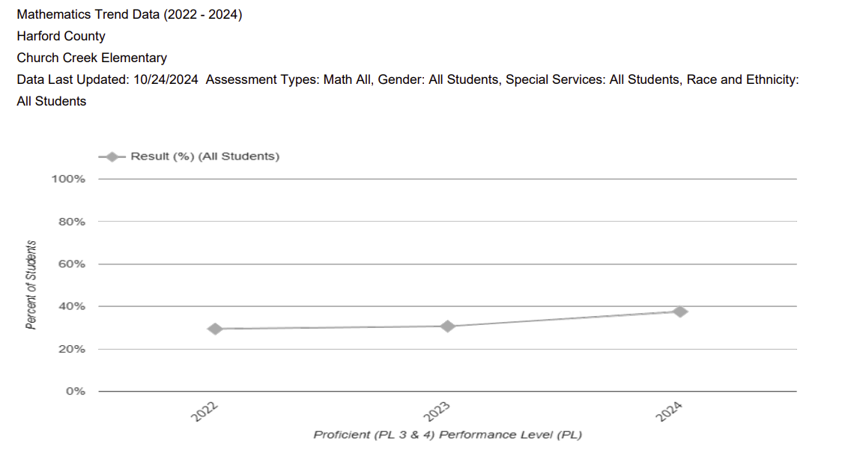

Church Creek Elementary, our partner school in Harford county has had significant gains in ELA scores from 35.6% of students proficient in ELA in 2022 to 47.9% proficient in 2024. In math, they have also had an increase in scores from 29.5% proficient in 2022 to 37.6% in 2024.